**Precalculus Name _______________________________**

**Vectors Basics WS**

1. **Find the component form of the vector with the following characteristics.**
2. **Initial Point (3, -2); Terminal Point (-2, 5)**
3. **P (-2, -4); Q (-6, 7)**
4. **Magnitude: 12; Θ = 135°**
5. **Magnitude: 25; Θ = 324°**
6. **Find the magnitude and direction of the following vectors. Make sure your answer puts you in the correct quadrant.**
7. $〈-3, 6〉$**c. $〈4, -9〉$**
8. $〈2, 7〉$**d. $〈-3, -1〉$**
9. **Find the unit vector for the following vectors.**
10. $〈-3, 6〉$**c. $〈4, -9〉$**
11. $〈2, 7〉$**d. $〈-3, -1〉$**
12. **Write the following vectors in linear form (v1i + v2j). Find the magnitude and direction of each.**

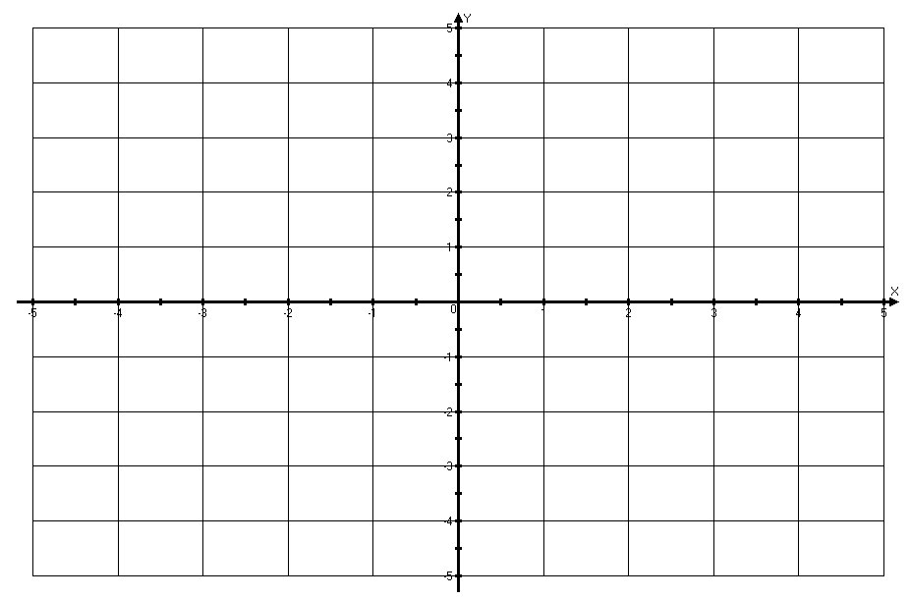

Use the vectors identified below:



5. a.  b. 

c. 

6. Which of the following pairs of points could be the initial point and the terminal point, respectively, for ?

a.  b.  c.  d. 

7. Write each of the 3 given vectors as a linear combination.

8. Find the direction angle for each of the 3 given vectors.

9. Find the resultant vectors.

a.  b.  c. 

d.  e.  f. 

Use the following vectors for the following questions. Then, for the resultant vector, find the component form, the magnitude, and the direction.



**w**

**v**

**u**

For each question:  
A) Do the operation graphically  
B) Find the component form of the resultant vector  
C) Find the magnitude of the resultant vector  
D) Find the direction of the resultant vector

1. 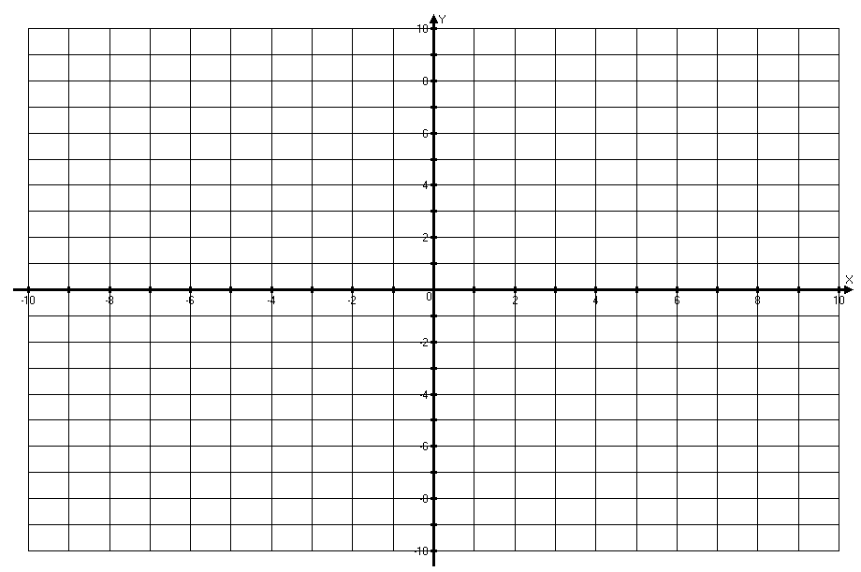u + v



1. u + w
2. v + v



1. u – v



1. w – u

Application: A plane is traveling at 580 mph with a bearing of 135°. A southwest wind is coming at the plane at 30 mph. What is the groundspeed and bearing of the plane as a result of the wind?