Pre-Calculus, Unit 4: Trig Identities Name: ________________________

SIMPLIFYING and VERIFYING Trig Identities WS Date: _____________

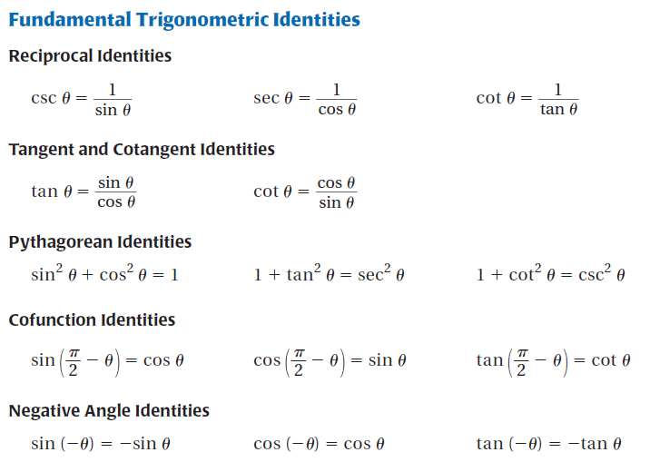

1. What does the cofunction identity $\sin\left(\frac{π}{2}-θ\right)=\cos{θ}$ tell you about the graphs of $y=\sin{x}$ and $y=\cos{x}?$

|  |  |  |  |  |  |
| --- | --- | --- | --- | --- | --- |
| **Find the values of the other five trigonometric functions of** *θ***.** | | | | | |
| **2.** | MathTypeHolder.wmf | **3.** | MathTypeHolder.wmf | **4.** | MathTypeHolder.wmf |
|  |  |  |  |  |  |
| **Simplify the expression.** | | | | | |
| **5.** | $$\sin{x}\cot{x}$$ | **6.** | $$\frac{\sin\left(-θ\right)}{\cos\left(-θ\right)}$$ | **7.** | $$\csc{θ\sin{θ+\cot^{2}θ}}$$ |
|  |  |  |  |  |  |
| **8.** | $$\cos{θ\left(1+\tan^{2}θ\right)}$$ | **9.** | $$1+\tan^{2}\left(\frac{π}{2}-x\right)$$ | **10.** |  |
|  |  |  |  |  |  |

|  |  |  |  |  |  |  |  |
| --- | --- | --- | --- | --- | --- | --- | --- |
| **11.** | $$\frac{\cos\left(\frac{π}{2}-θ\right)}{\csc{θ}}+\cos^{2}θ$$ | **12.** | $$\sin\left(\frac{π}{2}-θ\right)\sec{θ}$$ | | | **13.** | $$\frac{\cos^{2}x}{\cot^{2}x}$$ |
|  |  |  |  | | |  |  |
| **14.** | $$\frac{\sec{x\sin{x+\cos\left(\frac{π}{2}-x\right)}}}{1+\sec{x}}$$ | **15.** | $$\frac{\csc^{2}x-\cot^{2}x}{\sin\left(-x\right)\cot{x}}$$ | | | **16.** | $$\frac{\cos^{2}x \tan^{2}\left(-x\right)-1}{\cos^{2}x}$$ |
|  |  |  |  | | |  |  |
| **Verify the identity.** | | | | | | | |
| **17.** | $$\sin{x}\csc{x}=1$$ | | | **18.** | $$\tan{θ\csc{θ\cos{θ=1}}}$$ | | |
|  |  | | |  |  | | |
| **19.** |  | | | **20.** |  | | |
|  |  | | |  |  | | |