Graph the following inverse trig. functions. State the domain, range, and where applicable the asymptotes.
$1. y=\tan^{-1}{x-\frac{π}{4}}$ 2. g(x) = 4$\cos^{-1}{4x-45°}$

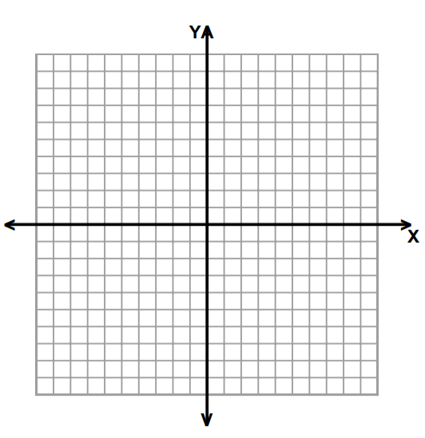

v

3. y(t) = sin⁻¹ 2(t – 3) 4. y = 2arccos ($\frac{x}{2}$ + 2) +$\frac{π}{6}$

v

5. f(t) = 315$°$ + 3arctan( $\frac{t}{2}-1)$ 6. f(x) = $\frac{1}{2}$arcsin (x – π)

v

Write an equation for the following graphs.
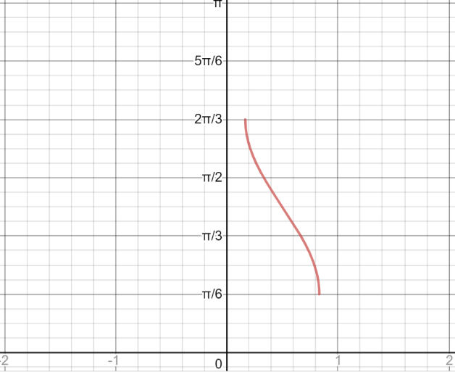
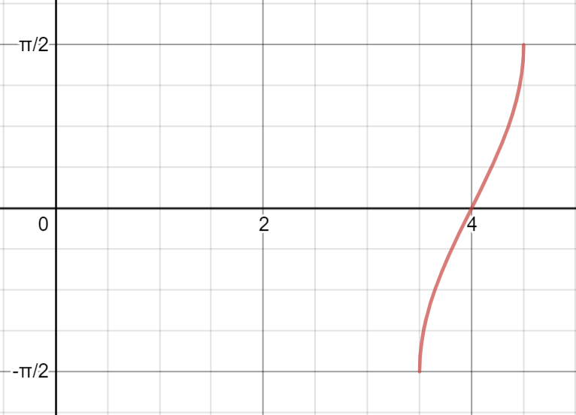
7. 8.

9. 