Pre-Calculus

Final Exam Review Guide

**Unit 1: Matrices**

1. Determine the order of 
2. . Solve the system of equations using matrices.



1. Evaluate .
2. Evaluate .
3. Simplify

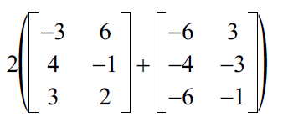

1. Simplify

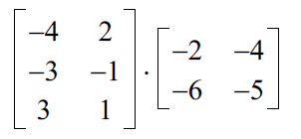

1. Solve the equation.

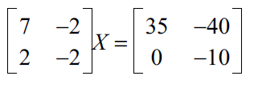

Solve the equation.

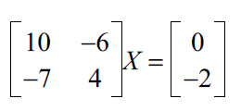

**Unit 2: Conics Section**

1. Find the center, vertices, foci and co-vertices of the ellipse .
2. . Find the standard form of the equation of the ellipse with vertices (- 3, 0), (7, 0) and foci (0, 0), (4, 0).
3. Find the center, vertices, and foci of the hyperbola 
4. Find the standard form of the equation of the hyperbola with vertices (- 10, 3), (6, 3) and foci (- 12, 3), (8, 3).
5. . Find the vertex, focus, and directrix of the parabola
6. . Find the standard form of the equation of the parabola with vertex (2, -3) and focus (-4, -3).

**Unit 3: Intro to Trig Functions**

1. Find the six trig functions of the angle  (in standard position) whose terminal side passes through (12, 16). (g)
2. Find the six trig functions of the angle  (in standard position) whose terminal side passes through (-3, 4).
3. Find the coterminal angles of $\frac{7π}{6}$.
4. Evaluate the exact value of cos(-135◦).
5. Evaluate the exact value of sin(-45).
6. A 40-foot extension ladder leans against the side of a building. Find the distance, h, up the side of the building the ladder extends if the angle of elevation of the ladder with the ground is . (g)
7. Evaluate:  Round to four decimal places. (g)

**Unit 4: Graphing Trig Functions**

1. Graph and find the period and amplitude if applicable of . (g)
2. Find the period and amplitude if applicable of . (g)
3. . Evaluate. a.  b.  (g)
4. Evaluate $sin⁡(\cos^{-1}(\frac{\sqrt{3}}{2})$.
5. Evaluate $tan⁡(\sin^{-1}(\frac{2}{3})$.
6. Graph $2\csc\left(4πx\right)-3$.
7. Graph $3\sin\left(θ+\frac{π}{6}\right).$

**Unit 5: Trig Identities**

1. Evaluate using sum or difference identities.
2. Given  and , find .
3. Use the fundamental identities to simplify .
4. Solve the equation. .
5. Solve the equation using double angle identities: $2\cos^{2}θ+cos2θ=2$.
6. Solve the equation using double angle identities: $2\sin^{2}2θ= \sin^{2}θ+sin2θ$.
7. Solve the equation $cos2θ=\cos^{2}θ.$
8. Solve the equation $3+\cot^{2}θ=3cscθ$.
9. Simplify the expression $-sinxcotx$.
10. Simplify the trig expression $\frac{cosx}{1-sinx}$.
11. Simplify the trig expression: $\frac{1}{1-cosx}+\frac{1}{1+cosx}$.

**Unit 6: Law of Cosines and Sines**

1. Find each measurement indicated.

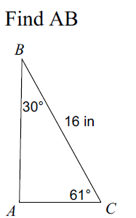

1. Find the measurement indicated.

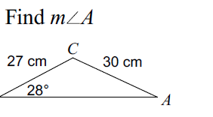

1. Solve each triangle.

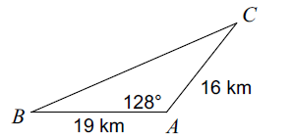

1. Solve each triangle.

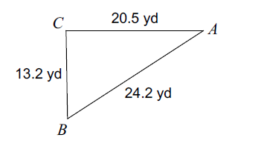

1. Solve each triangle.

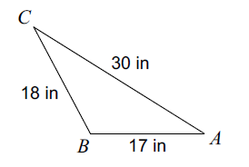

**Unit 7: Vectors**

1. Find the magnitude and direction angle for each vector.
$-3\sqrt{143}i-3j$

$15 i-20 j$

$p=<1, 3>$

$RS where R=(-3,-9)and S=\left(-6,-2\right).$

2. Find the component form of the resultant vector; **u = <-7,-3> unit vector in opposite direction of u.**
3. Find the measure of the angle between the vectors.
4. **u=-6i-3j; v = 3i – 7j**
5. **u=** **8i + 2j; v = -7i – 4j**
6. Find the dot product of ***a and b*** in #34.
7. A vector has initial point  and terminal point . Find its component form.
8. Given ***w*** =  and ***u*** = , find ***v*** = .
9. A vector ***v*** has initial point  and terminal point . Find its magnitude and direction.