Pre-Calculus
Final Exam Review
Unit 1: Matrices
- 2,4
- (5, -1, 2)
- $\left[\begin{matrix}-6 & 18 \\ 9 & -9\end{matrix}\right]$

- $[\begin{matrix}39 & 10 & 27 \\ 18 & 9 & 35\end{matrix}]$

- $\left[\begin{matrix}-18 & 18 \\ 0 & -8 \\ -6 & 2\end{matrix}\right]$

- $\left[\begin{matrix}-4 & 6 \\ 12 & 17 \\ -12 & -17\end{matrix}\right]$

- $\left[\begin{matrix}7 & -6 \\ 7 & -1\end{matrix}\right]$

- Center: (1,-4); V: (1,0) (1,8) CV(4,-4), (-2,-4) Foci (1, -4 ±$\sqrt{7})$

- $\frac{{(x-2)}^{2}}{25}+\frac{{(y)}^{2}}{21}=1$

- $\frac{{(x-1)}^{2}}{16}-\frac{{\left(y+1\right)}^{2}}{9}=1$; center (1,-1) vertices (1±4, -1); Foci (1±5, -1)

- $\frac{{(x+2)}^{2}}{64}-\frac{{\left(y-3\right)}^{2}}{36}=1$

- Omit

- $\left(x-3\right)=-24{(y+3)}^{2}$

- $sinx=\frac{4}{5}, cscx=\frac{5}{4}, cosx=\frac{3}{5}, secx=\frac{5}{3}, tanx=\frac{4}{3}, cotx= \frac{3}{4}$

- $sinx=\frac{4}{5}, cscx=\frac{5}{4}, cosx=-\frac{3}{5}, secx=-\frac{5}{3}, tanx=-\frac{4}{3}, cotx=- \frac{3}{4}$

- $\frac{19π}{6}, \frac{-5π}{6}$

- $-\frac{\sqrt{2}}{2}$

- $-\frac{\sqrt{2}}{2}$

- 37.09 ft.

- -1.1507

- 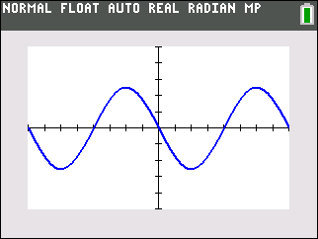period-2π; amplitude: $\frac{5}{2}$

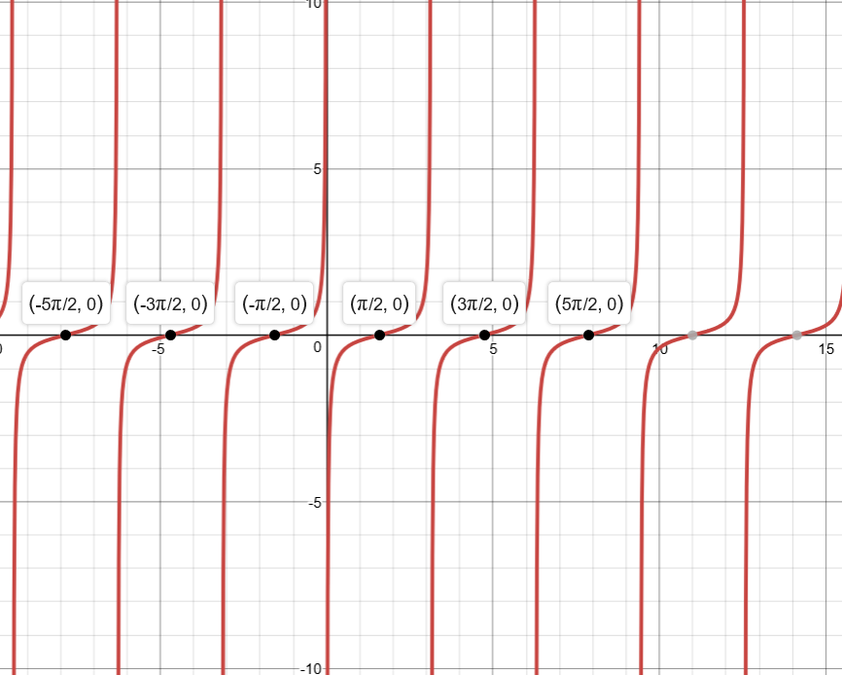
- $\frac{π}{4}$; $-\frac{π}{3} or-60°$

- $\frac{1}{2}$

- $\frac{\sqrt{5}}{3}$

- See graph

- See graph

- $\frac{\sqrt{2}+\sqrt{6}}{4}$

- $\frac{\sqrt{10}}{10}$

- 1+cotx

- $x=\frac{2π}{3}, \frac{4π}{3}, 0, 2π$

- $x=\frac{π}{6}, \frac{5π}{6}, \frac{7π}{6}, \frac{11π}{6}$

- $x=\frac{π}{2}, \frac{3π}{2}, \frac{π}{4}, \frac{3π}{4}, \frac{5π}{4}, \frac{7π}{4}$

- $x=0, 2π, π$

- $x=\frac{π}{6}, \frac{11π}{6}, \frac{π}{2}$

- -cosx

- Secx + tanx

- $2\csc^{2}x$

- 13.99

- $24.99=25°$

- A=31.48; B=$23.6°;C=28.4°$

- $A=33.1°, B=57.9°, C=89°$

- $A=32°, B=118°, C=30.03°$

