CCGPS Precalculus Name
Unit 2 Study Guide: Graphing Trigonometric Functions
- Know how to graph parent graphs and find the characteristics for sine, cosine, tangent, secant, cosecant, cotangent, cos⁻¹$θ$, sin⁻¹$θ,$ and tan⁻¹$θ$.
- Identify characteristics and graph two cycles of the transformed graphs.
- y = -cos(2x) + 5
Amplitude:
Period:
Sinusoidal Axis(midline):

Phase shift:
Frequency:
Domain:
Range:

- y = -3 + 4sin(3(x + π))
Amplitude:
Period:
Sinusoidal Axis:
Phase shift:
Frequency:
Domain:
Range:

- Write Equations from a graph.
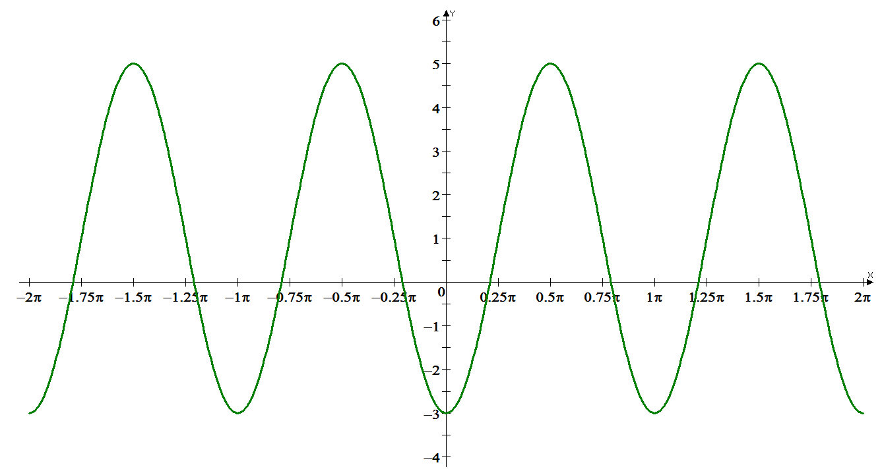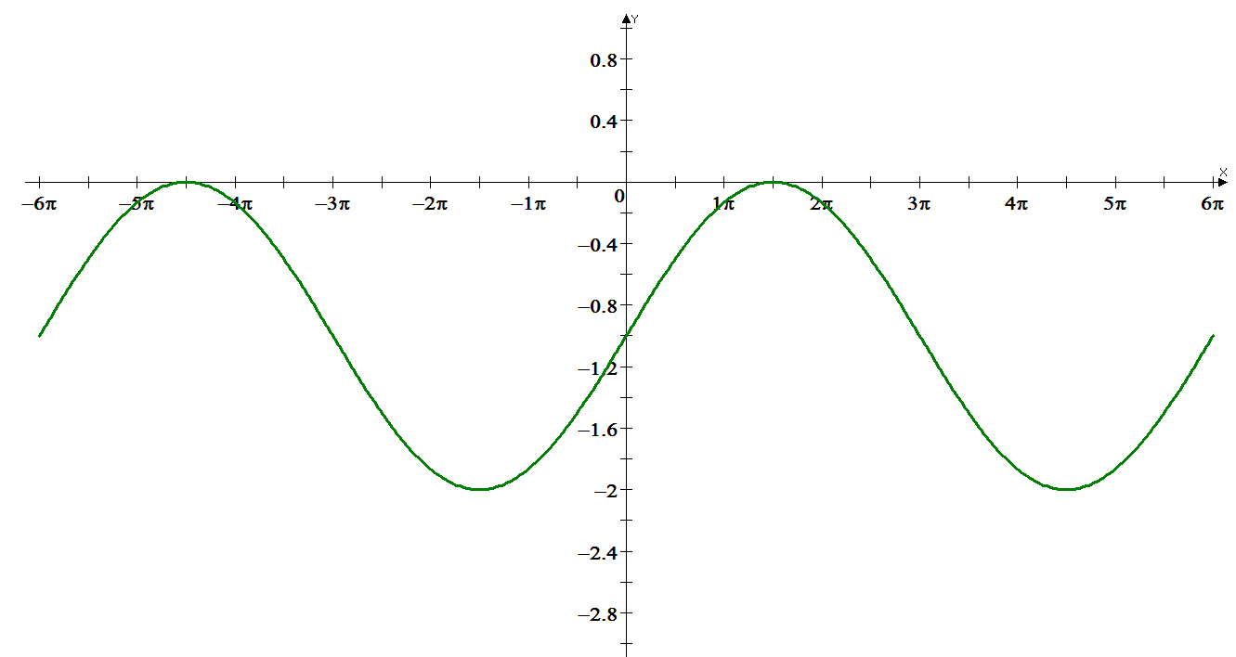

- Creating graphs given information
- Write an equation of cosine that fits the following characteristics.
Amp:2 period: $\frac{2π}{3}$ phase shift: -$π$ midline: y= -$\frac{7}{8}$

- Applications of Trig Functions.
There is a surfer floating on the ocean. She sees a wave that she will crest 5 seconds from now (t=0). The crest of the wave is 20 feet above the ocean floor. 12 seconds after she crests the wave, she will reach the trough at 4 feet above the ocean floor.
- Write an equation to represent the surfer’s periodic motion.
- How far above the ocean floor is she now?
- How far above the ocean floor will she be 2 minutes from now?
- When will the surfer be at 15 feet above the ocean floor?
- For how long at one stretch can the surfer stay below 10 feet above the ocean floor

Write a sinusoidal equation with the given characteristics.
1. Sine Curve  Max is 20 ft  Min is 2 ft  Period is 2.5 minutes | 2. Starts at a minimum  Sinusoidal axis is y=112  Amplitude is 27  Distance between a  consecutive max and min is 10 | 3. Starts at the center and  is falling  Min is -10  Amplitude is 25  Period is 12π

- Inverse Trig Functions
1. Graph the parent graphs for the three inverse trig functions.

- Explain why the domain and range are limited to the values they are.

- Graph y = sin⁻¹$2θ$ +$π$

- Graph y = 2tan⁻¹$(θ+$1)

